Gloria R. Carpeneto, Homily
Ascension Thursday (celebrated on 7th Sunday of Easter)
May 13, 2018
Acts 1:1-11; Ephesians 1:17-23; Mark 16:15-20; Psalm 47, Our God ascends to the judgment seat with shouts of joy; a blare of trumpets for our God.
Our Gospels are written to show us Jesus’ life as a journey, and our Lectionary is written so that we might follow the footsteps of Jesus on that journey throughout the liturgical year. Beginning in Advent every year, we walk with Jesus from birth through childhood & adolescence and into his adulthood. And we listen to his words. And with any luck, every year of walking with Jesus and hearing those same scriptures proclaimed again and again helps our lives meld more and more into the life of Jesus. As Jesus grows older in wisdom and grace, so do we. As Jesus slowly evolves into the understanding of who he is and why he is in this world, so do we. And as Jesus slowly comes to realize that he and the Father are one, he invites us into that same realization.
But one day, Jesus is crucified and it all ends. No more watching, no more listening. Like any other death, the death of Jesus leaves us bereft until – amazingly – he’s risen and we’re all back in business! Only now Jesus seems a bit more intense, more laser-focused in his teachings. It’s almost as though he knows that post-resurrection, he’s living on borrowed time, and he has to squeeze in every last word to those who most need to hear it. In our Lectionary readings on the Sundays after Easter, we hear the intensity of Jesus unpacking the scriptures to the disciples on their way to Emmaus. We hear him almost forcibly saying to Peter “Feed my sheep!” We hear him reassuring us that he is the shepherd who is of God, and that we are safe in his hands. He gives us a forceful commandment to love one another. He tells us that our hearts should not be troubled. And ultimately, he gives us peace.
And with that, Jesus is ready to move on, and this time for good. He has taught everything he can teach. There’s no more for him to say. Now, the spotlight shifts to us. With the Ascension comes a call to discipleship without the physical presence of the Risen Christ. We are sent out with the words “Go into the whole world and proclaim the Good News to all creation.”

It’s no wonder then that in our first reading, Jesus’ many disciples are seen standing with their mouths open looking up to heaven, even after Jesus was taken from their sight. I’m reminded of baby birds with their mouths wide open waiting to be fed. Only there will be no more feeding. “You, Galileans, why are you standing here looking up at the skies?” Who are we without the Teacher? How are we to proclaim the Good News to all creation? What are we gonna do?
Of course we all know that Pentecost is coming but that’s a homily for next week. What I want to say about the Ascension today is that before he left this earth, Jesus promised – intensely and repeatedly – that all would be well. He promised that his followers would be able to speak in tongues, expel demons, handle snakes. Or in situations closer to our reality, Jesus promised that we would know what to do about Ukraine, about Buffalo, about Uvalde, about Roe vs Wade, about racism and violence and all the problems that demand our discipleship today. Jesus promised to send us that very same Spirit that he came to know as his vital principle. And sharing that Spirit with the risen and ascended Christ, we cannot give up joy or the hope that all shall be well.
One of the documents of Vatican II might bring this point of joy and hope home to us today, especially since it’s entitled Gaudium & Spes, Joy & Hope. Hear these words from the Council …
The People of God believe that they are led by the Spirit of God who fills the whole world. Impelled by that belief, they try to discern the true signs of God’s presence and purpose in the events, the needs and the desires they share with the rest of humanity. For faith casts a new light on everything and makes known the full ideal which God has set for humanity, thus guiding the mind toward solutions that are fully human. (GS, 11)
So the People of God will always be led by the Spirit of God to relieve famine in Ethiopia, to eliminate brutality toward women in Afghanistan, to open their arms to Central American refugees at the border, to control mass murders in schools. Our human solutions might not happen in the time or in the way we might want. But we are assured that they will ultimately be the work of God’s Spirit.
So here we are on the Feast of the Ascension looking up at the sky with our mouths hanging open, wondering what to do. In this respect, the Feast of the Ascension is a lot like Holy Saturday – Jesus is gone, and we wait for what’s coming. . Maybe we wonder what Jesus is up to, now that he is no longer present to us. Well, here’s a thought for the week between Ascension and Pentecost.

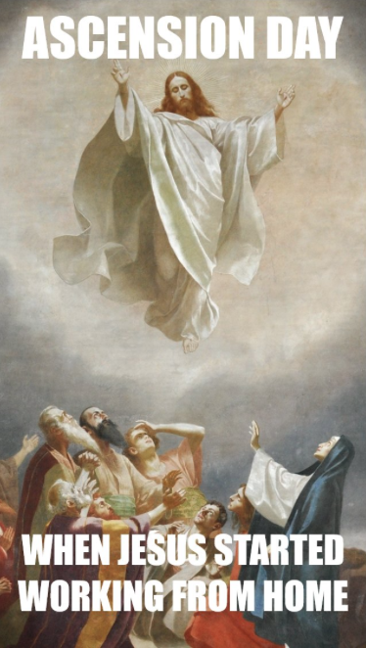
Just because Jesus has ascended doesn’t mean he’s not working from home! Pentecost will happen. All those tongues of fire will settle until a mighty wind blows the disciples out through the doors to preach the Gospel in every tongue. That’ll happen to us, too. Even without the physical presence of Jesus, we’ll receive the very Spirit of God on Pentecost and our tongues will be open to speak truth to power, healing words to those in pain, and comfort to those who grieve. Our hands will be open to healing. Our minds will be open to solutions to problems that connect us all as human beings.
Just hang in – no matter what happens, Jesus will always be working from home! AMEN.

